Borehole No. GM75
Location Nsareye, Afram Plains
Latitude N 07°01.870’
Longitude W000°34.152’
Date started 24/01/2000
Date completed 26/01/2000

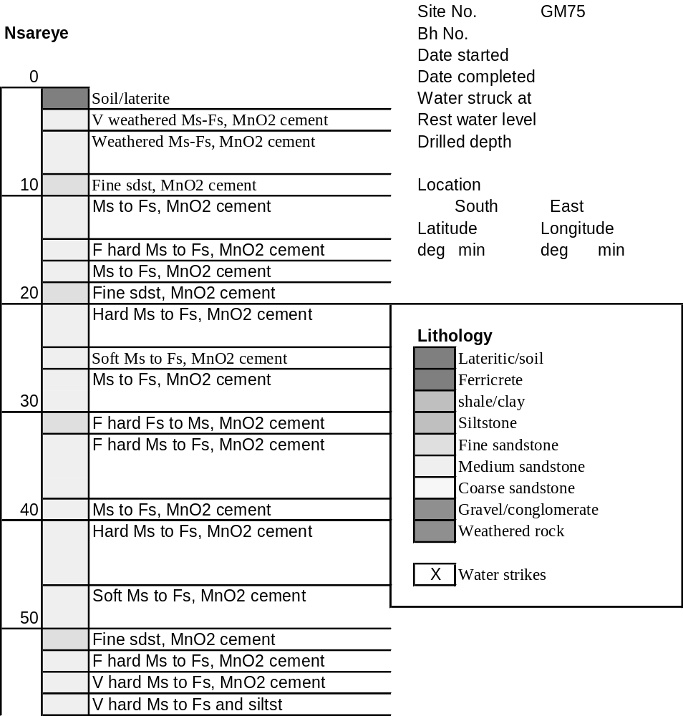

Summary Lithological Log
Depth(m)
From To
0 1 Soil/laterite
1 4.1 Soft very weathered medium to fine sandstone with manganese
cement
4.1 8.1 Fairly soft weathered medium to fine sandstone with manganese
cement
8.1 9.1 Fine sandstone with manganese cement
9.1 13.2 Medium to fine sandstone with manganese cement
13.2 15.2 Fairly hard medium to fine sandstone with manganese cement
15.2 18.3 Medium to fine sandstone with manganese cement
18.3 19.3 Fine sandstone with manganese cement
19.3 25.4 Very hard to fairly hard medium to fine sandstone with manganese
cement
25.4 27.4 Fairly soft medium to fine sandstone with manganese cement
27.4 30.5 Medium to fine sandstone with manganese cement
30.5 32.5 Fairly hard fine to medium sandstone with manganese cement
32.5 37.6 Fairly hard medium to fine sandstone with manganese cement
37.6 40.6 Medium to fine sandstone with manganese cement
40.6 45.7 Fairly hard to hard medium to fine sandstone with manganese cement
45.7 50.8 Fairly soft medium to fine sandstone with manganese cement
50.8 51.8 Fine sandstone with manganese cement
51.8 53.8 Fairly hard medium to fine sandstone with manganese cement
53.8 55.9 Very hard to hard medium to fine sandstone with manganese cement
55.9 56.9 Very hard medium to fine sandstone and siltstone

Detailed Lithological Log
Depth(m) Lithology
From To

Soil/laterite
0 1 Weathered grey white and orange clayey fine grained sand

Soft very weathered medium to fine sandstone with manganese cement
1 2 Red brown and black manganiferous and weathered medium to fine
grained sandstone with much fine crystalline MnO
2 3 Red brown very weathered and soft medium to fine grained sandstone
with many orange pink grains and black finely crystalline MnO cement
3 4.1 Red brown very weathered and soft medium to fine grained sandstone
with orange pink grains and black finely crystalline MnO cement

Fairly soft weathered medium to fine sandstone with manganese cement
4.1 5.1 Dark brown medium to fine grained weathered sandstone, soft platy
fragments with some pink grains and black MnO cement
5.1 6.1 Dark red brown medium to fine grained sandstone, weathered and
fairly soft with pink grains and some black MnO cement
6.1 7.1 Dark red brown medium to fine grained sandstone, weathered with
many orange pink grains and some black MnO cement
7.1 8.1 Dark red brown medium to fine grained sandstone, weathered with
many orange pink grains and some black MnO cement; subordinate
hard light orange grey medium to fine grained sandstone with some
black MnO cement

Fine sandstone with manganese cement
8.1 9.1 Dark brown black fine grained sandstone, with few pink grains and
much black MnO cement

Medium to fine sandstone with manganese cement
9.1 10.2 Dark red brown medium to fine grained sandstone with many orange
pink grains and some black MnO cement
10.2 11.2 Dark red brown medium to fine grained sandstone with many orange
pink grains and some black MnO cement; subordinate lighter orange
grey granitic medium sandstone with no MnO cement
11.2 12.2 Dark red/brown medium to fine sandstone with pink grains and black
MnO cement
12.2 13.2 Dark red/brown medium to fine sandstone with pink grains and black
MnO cement, very soft platy fragments

Fairly hard medium to fine sandstone with manganese cement
13.2 14.2 Dark red brown, pink and black fairly hard medium to fine grained
sandstone with many pink grains and some black MnO cement
14.2 15.2 Dark red brown, pink and black fairly hard medium to fine grained
sandstone with many pink grains and some black MnO cement

Medium to fine sandstone with manganese cement
15..2 16.3 Dark red brown medium to fine grained sandstone with pink grains and
black MnO cement; subordinate light grey well cemented sandstone
with some orange grains
16.3 17.3 Dark red brown medium to fine grained sandstone with pink grains and
black MnO cement; subordinate pink red medium sandstone with less
MnO cement and some dark red brown fine grained sand with much
black MnO cement
17.3 18.3 Dark red brown medium to fine grained sandstone with pink grains and
black MnO cement

Fine sandstone with manganese cement
18.3 19.3 Dark purple brown fine grained manganiferous sandstone

Very hard to fairly hard medium to fine sandstone with manganese cement
19.3 20.3 Very hard dark red brown medium to fine grained sandstone with
many orange pink grains in parts and platy mica like MnO and black
cement
20.3 21.3 Dark red brown, black and pink fairly hard medium to fine grained
sandstone with many orange grains and black MnO cement;
subordinate light grey green blue chlorite or mudstone partings
21.3 22.4 Dark greyish purple and black hard medium to fine grained sandstone
with some pink grains and black MnO as cement and pseudo-mica
22.4 25.4 Dark brown purple and black fairly hard platy fragments of medium to
fine sandstone with pink grains and black MnO cement

Fairly soft medium to fine sandstone with manganese cement
25.4 26.4 Dark purple brown and black medium to fine grained fairly soft
sandstone with pink grains and black MnO cement
26.4 27.4 Dark black brown fairly soft to fairly hard medium to fine grained
sandstone with some pink grains and much MnO cement

Medium to fine sandstone with manganese cement
27.4 28.4 Dark red brown medium to fine grained sandstone with pink grains and
black MnO cement
28.4 29.5 Dark red black medium to fine grained sandstone with pink grains and
much black MnO cement; subordinate dark red mudstone fragments
29.5 30.5 Dark red brown medium to fine sandstone with pink grains and black
MnO cement; subordinate black red manganiferous fine grained
sandstone

Fairly hard fine to medium sandstone with manganese cement
30.5 31.5 Dark red/purple fine to medium sandstone fairly hard to hard with
much black MnO cement and pseudo-mica, also pink grains
31.5 32.5 Fairly hard black manganiferous fine grained sandstone with
subordinate platy soft dark pink-red fine grained sandstone, no black
cement

Fairly hard medium to fine sandstone with manganese cement
32.5 33.5 Fairly hard dark red brown medium to fine grained sandstone with
many pink grains and some black MnO cement
33.5 34.5 Fairly hard dark red brown medium to fine grained sandstone with
many pink grains and some black MnO cement
34.5 35.6 Fairly hard dark red brown medium to fine grained sandstone with
many pink grains and some black MnO cement
35.6 36.6 Fairly hard dark red brown medium to fine grained sandstone with
many pink grains and some black MnO cement
36.6 37.6 Fairly hard dark red brown medium to fine grained sandstone with
many pink grains and some black MnO cement; subordinate light
orange and grey medium to fine grained sandstone with some black
MnO cement

Medium to fine sandstone with manganese cement
37.6 38.6 Dark purple brown and black ferruginous and manganiferous fine to
medium sandstone with few pink grains.
38.6 39.6 Dark purple brown ferruginous medium to fine grained sandstone with
orange/pink grains and black MnO cement; subordinate light orange
and grey sandstone
39.6 40.6 Dark reddish brown medium to fine ferruginous sandstone with pink
grains and black MnO cement and pseudo-micas

Fairly hard to hard medium to fine sandstone with manganese cement
40.6 41.7 Dark black brown medium to fine sandstone, ferruginous and very
manganiferous, hard with some pink grains
41.7 42.7 Fairly hard dark red brown medium grained sand with many pink
grains and some black MnO cement, softer and more platy where >
MnO cement
42.7 43.7 Dark grey medium and fine grained fairly hard sandstone with many
pink grains and some black MnO cement; odd fragment of light blue
grey chloritic mudstone
43.7 44.7 Fairly hard red brown medium to fine grained sandstone with many
pink grains with little black MnO cement
44.7 45.7 Fairly hard dark purple red medium to fine grained sandstone with
pink grains and much black MnO cement especially in fine grained
sandstone

Fairly soft medium to fine sandstone with manganese cement
45.7 48.8 Dark red brown and black medium to fine grained sandstone, fairly
soft with some pink grains and black MnO cement
48.8 49.8 Dark purple brown ferruginous medium to fine grained sandstone,
fairly soft with some pink grains and black MnO cement; odd light
blue green grey fragment of siltstone
49.8 50.8 Dark purple brown ferruginous medium to fine grained sandstone with
some MnO cement

Fine sandstone with manganese cement
50.8 51.8 Dark brown ferruginous fine grained sand with some black MnO
cement

Fairly hard medium to fine sandstone with manganese cement
51.8 52.8 Dark brown and black fairly hard medium to fine grained sandstone
with many pink grains and some black MnO cement, silicified? in parts
52.8 53.8 Dark red/brown to dark red/black medium to fine grained sandstone
with some pink grains and black MnO cement

Very hard to hard medium to fine sandstone with manganese cement
53.8 54.9 Dark brown very hard medium to fine grained sandstone with some
pink grains and black MnO cement; odd fragment of grey micaceous
fine grained sandstone
54.9 55.9 Dark brown/black, dark red/brown and black medium to fine grained
sandstones with variable amounts of black MnO cement

Very hard medium to fine sandstone and siltstone
55.9 56.9 Very hard dark purple/brown and black medium to fine grained
sandstone with some light orange and grey sandstone with light blue
grey siltstone.

